Electronically Recorded Document *****

# Cameron County

## Sylvia Garza-Perez Cameron County Clerk Brownsville, Texas

### Document Number: 201740928

|  |  |
| --- | --- |
| Recorded As | ELECTRONIC RECORDING |
| Recorded On: | October 27, 2017 |
| Recorded At: | pm |
| Number of Pages: | 3 |
| Book-VI/Pg: | Bk-OR VI-22976 Pg-112 |
| Recording Fee: | $40.00 |

Parties:

## Direct- COTTONWOOD CREEK PROPERTY OWNERS INC

Indirect- PUBLIC

Receipt Number: 838913

### Processed By: Hilary Dittman



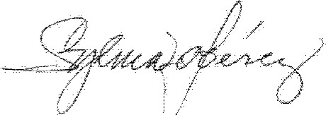I hereby certify that this instrument was filed on the date and time stamped hereon and was duly recorded in the Official Public Records in Cameron County, Texas.

COTTONWOOD CREEK PROPERTY OWNERS, INC.

DELINQUENT ASSESSMENT PAYMENT PLAN POLICY

The Cottonwood Creek Property Owners, Inc. ("Association") refers to property(s) shown in Cameron County Map Records of

Cottonwood Creek Map Records Cl-479A, CI „3486 and as shown in Map Records of the Fairways C I-1602B and Clu2017A. The Association constitutes a property owners association under the provisions of Chapter 2()9 of the Texas Property Code ("the Code") and is composed of fifteen (15) or more lots;

In order to comply with Sections 209.0062 and 209.0063 of the Code, the Board of Directors of the Association (the "Board") hereby adopted on October 26; 2017 the following Delinquent Assessment Payment Plan Policy:

#### Eligibility for Payment Plan

Subject to the terms of the Policy, a member of the Association who is delinquent in the payment of any regular or special assessments, or any other amounts owed to the Association, including costs of collection incurred by the Association (hereinafter referred to collectively as the Delinquent Assessments) shall be entitled to enter into a payment plan agreement with the Association that allows such member to pay the Delinquent Assessment in installment payments without incurring additional monetary penalties (hereinafter referred to as "Payment Plan Agreement"), Each such Payment Plan Agreement shall be in accordance with terms of these Payment Plan Guidelines and the requirements of Section 209.0062 of the Code.

Notwithstanding the foregoing, or any provision herein to the contrary, a member of the Association shall be ineligible to pay his/her Delinquent Assessments under a Payment Plan Agreement if such member has failed to honor the terms of a previous

Payment Plan Agreement with the Association and it has been less than two (2) years since the member's default under the previous Payment Plan Agreement.

##### 2. Payment Pfail Administrative Charge A!2d interest

In addition to the Delinquent Assessment: a member of the Association who enters into a Payment Plan Agreement shall be required to pay the Association reasonable costs associated with preparing the Payment Plan Agreement and administering the member's compliance with the Payment Plan Agreement (hereinafter to collectively as the "Payment Plan Administrative Charges"). A member of the Association who enters into a Payment Plan Agreement with thc Association shall also be required to pay all interest due and payable on the member s s Delinquent Assessment in accordance with applicable provisions of the Association's governing documents, which shall continue to accrue on the Delinquent Assessrnent during thc term of Payment Plan Agreement.

##### 3, Payment Schedule

The minimum term for a payment plan offered by the Association is three months. In extenuating circumstances in which repayment within three (3) months is not reasonable, the Association will follow Texas law in establishing a Payment Schedule. The Board of Directors must approve any repayment schedule beyond three (3) months.

##### 4. Payment Pian Agreernent

Each Payment Plan Agreement shall be evidenced in writing and executed by both the member and a duly authorized representative of the Association. The Payment Plan Agreement shall specify the total amount of Delinquent Assessments owed to the Association as of the date of the Payment Plan Agreement, the total amount of Payment Plan Administrative Charges and interest to be paid under the Payment Plan Agreement, and the term of the Repayment Schedule.

##### 5. Default of Payment Plan Agreement

Each payment due under any Payment Plan Schedule shall be due and payable to the Association on or before the first (l st) day of each month during the term of the Payment Plan Agreement. Time is of the essence with respect to payments under a Payment Plan Agreement, and the obligation to pay each monthly payment on or before the first (l st) day of each month must be strictly complied with. If a monthly payment made pursuant to a Payment Plan Agreement is returned for insufficient funds and/or if a payment is received after the due day thereof, it shall constitute a material breach of the Payment Plan Agreement. In such event, all unpaid amounts subject to the Payment Plan Agreement shall automatically, without any further notice from the Association, be accelerated and shan be immediately due and payable in full to the Association.

In such event, the member shall be considered in default of the Payment Plan Agreement until s/he pays the full amount of the accelerated Delinquent Assessment, Payment Plan Administrative Charges, and accrued interest subject to the Payment Plan Agreement to the Association (the "Payment Plan Dcfault Period"). In addition, the defaulting member shall be liable for ail costs of collection, including attorneys fccs, incurred by the Association to collect any rernaining unpaid amounts subject to the Payment Pian Agreement, which shall bc added to an included within thc Delinquent Assessment that rnust be paid by the dcfau)ting member to the Association undcr such Payment Plan Agreement, Any payment received by the Association from a member of the

Association who is in default under a Payment Plan Agreement with the Association during a Paymcnt Plan Default Period shall bc applied to the member's debt or account in thc following order of priority: (a) Any attorneys fees or third-party collection costs incurred by the Association in Connection with collection of the member's debt; (b) Any other fees and expenses reimbursable to the Association in connection with collection of the member's debt; (c) Any late charges and interest due by the member; (d) Any past-due delinquent assessments (beginning with the oldest); (e) Any current assessments; (L) Any other amount owed to the Association (excluding tines); and (g) Any fines assessed by the Association,

#### 2017

CCPOI Delinquent Assessment Payment Pian Policy — Page 2

##### 6. Application of Payments

Any payments received by the Association from a member of the Association under a Payment Plan Agreement with the Association shall be applied to the member's debt or account in accordance with Texas Property Code section 209.0063.

##### CERTIFICATION

IN WITNESS WHEREOF, the undersigned, Elizabeth Jane Craig, as the duly elected, qualified, and acting Secretary of the Cottonwood Creek Property Owners, inc. a Texas nonprofit corporation, hereby certifies on behalf of the Association that this

Payment Plan Guidelines Policy and Application of Payments Schedule was duly adopted by the Board of Directors of the

Association at a meeting of the Board on October 26, 2017, and shall take effect upon its recording in the Official Public Records of Cameron County, Texas.

COITONWOOD CREEK PROPERTY OWNERS, INC.,

A Texas Nonprofit Corporation

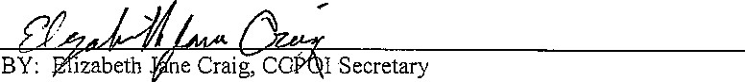

##### SEAL

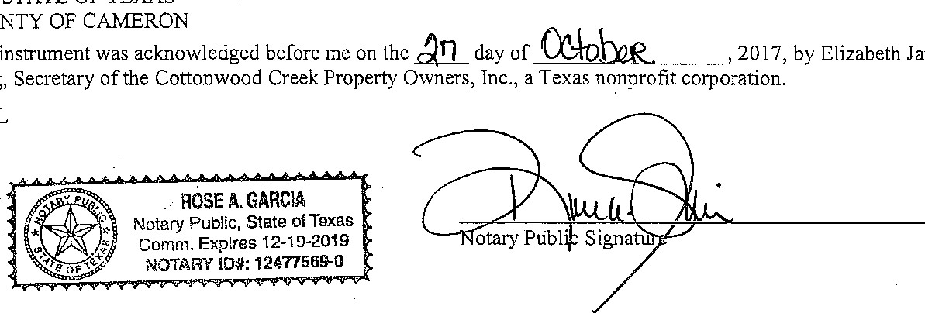

This

Craig,

Jane

COUNTY

THE

STATE

OF

TEXAS